Provincial Conference for Volunteer Engagement Professionals
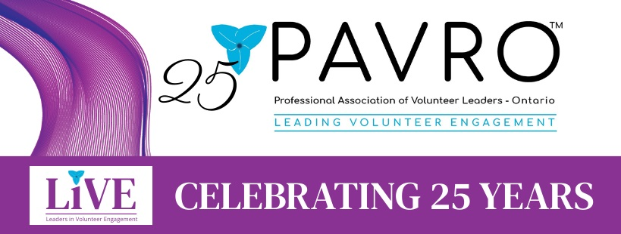

Professional Association of Volunteer Leaders – Ontario
PAVRO L!VE: CELEBRATING 25 YEARS
May 11 & 12, 2023
Centennial College Event Centre
937 Progress Avenue, Scarborough, ON M1G 3T8
2023 Sponsorship Opportunities

Conference Information: PAVRO L!VE 2023: Celebrating 25 Years
Dates: Thursday May 11 and Friday May 12, 2023
Venue: Centennial College Event Centre
937 Progress Avenue, Scarborough, ON M1G 3T8
Expected Delegates: 120 (per day)
This sponsorship package is your invitation to become a part of the 2023 Provincial Conference for Volunteer Engagement Professionals, the premier forum for sharing the latest ideas, trends, and strategies for volunteer engagement professionals. Hosted by the Provincial Association for Volunteer Leaders-Ontario (PAVRO), this annual conference brings together leaders of volunteers from across the province, whose work and dedication to our communities result in the betterment of society for all.
This year, PAVRO celebrates its silver anniversary! For 25 years, PAVRO, in its pursuit of excellence, builds individual, organizational, and community capacity to effectively engage volunteers through the professional management of volunteer resources. We invite you to join us in our celebrations by becoming a PAVRO L!VE 2023 conference sponsor.
This package outlines opportunities for you, your company or organization to be represented and remembered among the thought leaders, decision-makers, and community enablers who attend our annual conference. Align your company with our conference to celebrate the trailblazers who laid the foundations of the profession in Ontario, empower today’s leaders as they revitalize volunteer engagement following the global pandemic, and encourage tomorrow’s rising stars to continue building a province where the professional management and leadership of volunteers is respected, valued, and recognized as essential to a civic society.
Sponsorship Contact:
Johanne Deschamps
Administrator, PAVRO
pavro@pavro.on.ca

SPONSORSHIP LEVELS AND BENEFITS
 | PARTNER  $750 | PREMIUM  $1,500 | PINNACLE  $2,000 | PLATINUM  $3,000
Conference web page recognition (w/logo and link to organization)
Social Media promotion (LinkedIN, Facebook, Twitter, Instagram)
Colour logo included in all e-blast delegate communications
Promo items included in delegate bags
Included in Sponsors Slide Show displayed on way-finding screens
Podium recognition on both days of conference
Complimentary registration (1 person) for one day of conference
Complimentary registration (1 person) for both days of conference
Two (2) minute video spot featuring your company highlighted on conference web page as well as shown on Day 1 of conference.
Complimentary full PAVRO membership for one year

A LA CARTE SPONSORSHIP OPPORTUNITIES
 | Benefit
Bursary Patron: $400 per bursary  PAVRO offers members who might not otherwise be able to afford to attend conference, the opportunity to apply for a conference bursary. | - Conference page recognition as a Bursary Patron  - Recognition in bursary recipient’s letter of confirmation  - Logo on bursary promotional materials  - Included on Sponsors Slide Show on way-finding screens
Coffee Break Sponsor: $125 | - Name and logo on signage on coffee cart
Delegate Tote Bag: $650 | - Logo on tote bag  - Promo item/business information included in bag.  - Included on Sponsors Slide Show on way-finding screens
Delegate Networking Event Sponsor: $600 | - Name and logo on signage at event  - Conference page recognition as Networking Event Sponsor  - Included in Sponsors Slide Show on wayfinding screens.  - Logo displayed on screen during event
Photo Booth Sponsor: $500 | - Name and logo on signage at Photo Booth  - Included on Sponsors Slide Show on way-finding screens
Speaker Sponsor: $300 per speaker | - Conference page recognition as a Speaker Sponsor  - Included on Sponsor Slide Show displayed on wayfinding screens  - Podium recognition by room host prior to presentation

ADVERTISING & IN-KIND DONATIONS
 | BENEFIT
Business Card Promotion (Online): $25 | - Promoted on Conference web page
Business Card Promotion: $50 | - Promoted on Conference web page.  - Included in Sponsors Slide Show on way-finding screens
Business Advertisement: $85 | - Promoted on Conference web page.  - Advertisement sent via e-blast to delegates.  - Included in Sponsors Slide Show on way-finding screens
In-Kind Donations: items such as pens, notepads, USBs, etc. | - Included in delegate package.  - Logo included on Sponsors Slide Show on wayfinding screens.  - Minimum # of items: 130

PAVRO LiVE 2023: Celebrating 25 Years!
Conference Sponsorship Form
Contact Information:
Name: _________________________________________________________
Title: ___________________________________________________________
Email: __________________________________________________________
Tel #: __________________________________________________________
Company: _______________________________________________________
Address: ________________________________________________________
City: ___________________________________________________________
Prov: ___________________________________________________________
Postal Code: _____________________________________________________
I have reviewed the 2023 Conference Sponsorship Package and would like to support the PAVRO L!VE 25th Anniversary Conference at the following levels:
Category | Cost | Selection
Partner Sponsor | $750
Premium Sponsor | $1,500
Pinnacle Partner | $2,000
Platinum Partner | $3,000
Bursary Patron | $400 (per bursary)
Coffee Break Sponsor | $125 (per break)
Delegate Tote Bag | $650
Delegate Networking Event | $600
Photo Booth Sponsor | $500
Speaker Sponsor | $300 (per speaker)
Business Card Promotion (online) | $25
Business Card Promotion (at event) | $50
Business Advertisement | $85
In-Kind Donation
Contact Johanne Deschamps at pavro@pavro.on.ca or call 416-907-1007 for payment arrangements.

